Paper title (format “Title”, max. two lines, centered, no abbreviations)
First name Last name¹, First name Last name^{1*}, First name Last name², … (format “Author”)
¹ Name affiliation 1 (e.g. University, Institute), City, Country (format “Affil.”)
² Name affiliation 2 (e.g. University, Institute), City, Country

*Corresponding author email: email@address
Abstract (format “Head1 no number”)
(format “1st Para.”) The present template document illustrates the format that must be used in the preparation of full papers and extended abstracts for the fib Symposium 2027. Papers must be submitted in American English based on the submitted original abstract. The abstract is an objective representation of the paper, and should contain between 200 and 300 words. Try to provide a concise summary that accurately reflects the content; 300 words is the absolute maximum, and you do not need to utilize this limit. Please avoid several paragraphs, abbreviations, citations, figures. A maximum of five keywords must be given after the abstract section, formatted in italics, divided by commas and with a dot after the last keyword. Omit the abstract paragraph, if you intend to submit an “Extended abstract”.
Keywords: keyword1, keyword2, keyword3, keyword4, keyword5. (format “KeyW”)

Overall guidelines (format “Head1”)
(format “1st_Paragr” = first paragraph following a heading, a table, a figure, a list, an equation) This template exemplifies the correct format for the preparation of full papers for fib 2027 to ensure publication consistency and quality. Fulfillment of scientific and formal requirements as well as final registration and payment of the presenting authors are the mandatory requirement for paper acceptance and publishing. Note the spacing, punctuation and capitalization in all the examples below.
(format “BodyText”) Authors may choose between the options “full paper” (maximum of 8 pages) and “extended abstract” (maximum of 3 pages). The maximum lengths of the submissions are specified in Table 1. The page limits apply to the entire contribution including title, authors, affiliations, (abstract only in case of full paper,) keywords, text, figures, tables, reference list, and acknowledgments. If the page limit is not adhered to, the submission in question will be returned to the authors for revision. After a positive review, a revised version must be submitted.
Table 1. Paper lengths in total. (format “TabHead”)
Long version variant (format ”Tab1stLine”) | Maximum allowed number of pages
Full paper (format “TabContent”) | 8
Extended abstract | 3

(format “1st_Paragr” after a table) Deadlines for submission are available on the symposium website. The presented research must be original and should not be published elsewhere. Full papers and extended abstracts will be published electronically in the proceedings.
(format “BodyText”) Use the ConfTool platform for submission. Submissions via email will not be accepted. It is necessary to upload your submission both as MS word and as pdf file. The total size of the two files is limited to 10.0 MB (megabytes). Please contact us if you need help regarding the file size. As always with a conversion to PDF, authors should very carefully check a printed copy to avoid some conversion problems that usually occur with figures, drawings, text boxes and equations. Authors should perform a careful check to identify and correct all conversion errors. We recommend the option “high-quality printing”.
When submitting the final version of the paper, it is mandatory to update title, keywords, and abstract on the ConfTool platform. Otherwise, this may result in inaccuracies in the conference program.

Text layout

General information (format „Head2“)
(format “1st_Paragr”) Overall settings:
- Paper format: 210 mm × 297 mm (A4) (format “List-Bullets”);
- Margins: 2.5 cm top, bottom, left and right;
- Page numbering: will be added later by the publishers (not by the authors).
(format “1st_Paragr” after a list) Information regarding type setting:
- Type font: Times New Roman (size depends on format, see Table 2) (format “List-Numbers”);
- Single spacing;
- Don’t style the text manually (only use the defined formats);
- Don’t use bold, except for the headings, first lines in tables, and to denote vectors in mathematics;
- Don’t underline any text.
- Don’t use letter spacing.
- Don’t use more than one space after each other.
(format “1st_Paragr” after a list) The formatting is given in detail in Table 1. Usage is shown in this template.
Table 2. Typographical settings.
Section | Format title | Font specifics |  | Paragraph description
 |  | style | size in (pt) | spacing in (pt) |  | alignment
 |  |  |  | before | after
Paper title | Title | bold | 15 | 18 | 18 | centered
Authors | Author | regular | 11 | 0 | 12 | centered
Affiliations | Affil. | regular | 10 | 0 | 0 | centered
Headline | Headline | regular | 8 | 0 | 0 | centered
Keywords | KeyW | italics | 10 | 10 | 0 | left
1st level heading | Head1 | bold | 13 | 18 | 6 | left
2nd level heading | Head2 | bold | 11 | 12 | 6 | left
3rd level heading | Head3 | bold | 10 | 0 | 0 | justified
Headings of sections Abstract, References, Acknowledgement | Head1 no number | bold | 13 | 18 | 6 | left
Body text | BodyText | regular | 10 | 0 | 0 | justified
1st paragraph body text | 1st_Paragr | regular | 10 | 0 | 0 | justified, 1st line with 0.5 cm indent
Bullet point list | List-Bullets | regular | 10 | 6 (1st point) | 6 (last point) | left/justified; 0.5 cm indent
List with numbers | List-Numbers | regular | 10 | 6 (1st point) | 6 (last point) | left/justified; 0.5 cm indent
Equation | Eq | regular | 10 | 0 | 0 | centered; number in () right aligned
Formula symbol |  | italics | 10
Unit |  | regular | 10
Figure caption | FigCap | italics | 9 | 3 | 12 | centered
Figure | Fig | regular | 9 | 9 | 3 | centered
Table heading | TabHead | italics | 9 | 12 | 6 | centered
Table top rowe | Tab1stLine | bold | 10 | 0 | 0 | left; –0.19 cm left indent
Table content | TabContent | regular | 10 | 0 | 0 | left; –0.19 cm left indent
References | Ref | regular | 9 | 0 | 0 | justified; 0.5 cm hanging indentation

Please add blank lines in format “BodyText” or “1st Para.”:
- After a table, if it is not followed by a heading,
- Before a figure,
- Between affiliations and corresponding author,
- Before and after a paragraph starting with a heading level 3 (see section 2.2);
- Exception: Line space directly between formulas can be reduced to 6 pt.

Headings and headline
Structure your paper by headings of level 1 and 2. Only two levels of headings must be numbered. One lower level heading is allowed, but it remains unnumbered. At level 3, run-in heading is possible. To do this, select the relevant word or phrase and then apply the format “Head3” to it. Examples are shown in the following sections.
In the headline, please give the authors’ names as follows:
- One author: First name Last name
- Two authors: First name Last name1 and First name Last name2
- Three and more authors: First name Last name1 et al.

Figures and tables
Locate each figure/table close to its first reference in the text (or at the first appropriate location). Both should be centered within the page width, numbered separately, and should fit within the type area width of 160 mm. Multiple figures should be referred using letters, e.g., see Fig. 1a and Fig. 1b, or see Figs. 1a, b, or “left/middle/right”, e.g., Fig. 1 left. Please use consequently the first or the second version, do not mix!
Place table headings and figure captions centered and use a dot at the end. The content should be as concise and precise as possible, but also detailed enough. For images from other sources, a copyright information is required (please include it in parentheses); for own images, we recommend to include it.

Table style. ( format “Head3”) Please format text in tables left-aligned. The top and bottom of the table is marked with a horizontal black line (1 pt line width). The bottom of the top row of the table is also marked by a
1-pt line. If necessary, it is possible to structure the table body with horizontal ½ pt thin, black dashed lines. Vertical lines should not be used in tables
Avoid abbreviations in column headings.
Add definition in words if you use formula symbols.

Photographs, drawings, and diagrams. ( format “Head3”) Imagery can be in black/white or full color. As a rule: keep figures as simple as possible. Figures should be included in the body of the paper (not at the end), see Fig. 1. Don’t place any text next to a figure. Avoid placing text between figures as readers might not notice the text.
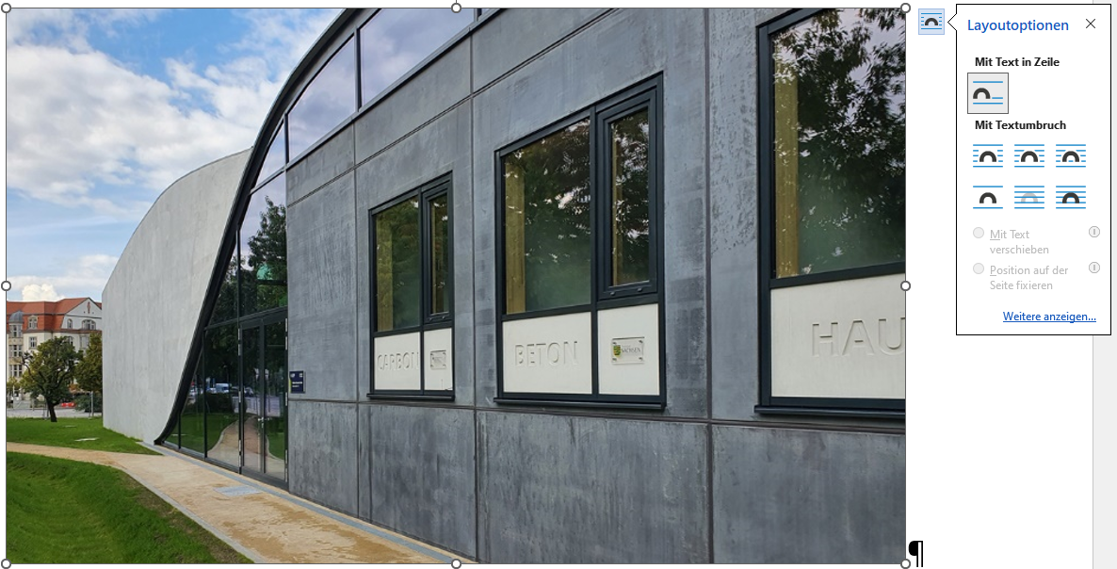 (Format “Fig”)
Fig. 1. Example how you should insert a figure in this template. (Screenshot and photo: Silke Scheerer) (format “FigCap”)
The resolution of line graphs should be chosen to at least 600 dpi. We recommend to use the TIF or png format for insertion. For bitmap pictures, a resolution of 300 dpi is sufficient.
Rules regarding figure design (please see also Fig. 2a versus Fig. 2b, and Fig. 3 left/right):
- Plot lines should be at least 0.2 mm thick,
- Include only necessary text,
- Ensure legibility of text (min. 7…8 pt font size), incl. legends,
- Ensure sufficient contrast and sharpness,
- Avoid very light and very dark images,
- No frames around diagrams,
- Avoid empty space around the content of a figure,
- Always label axis names with the value shown in words (optionally followed by the symbol) and the unit in round brackets.
- In the legend, use concise but clear labels whenever possible. These do not necessarily have to match, for example, the exact internal test specimen designation in your test program.
(a) 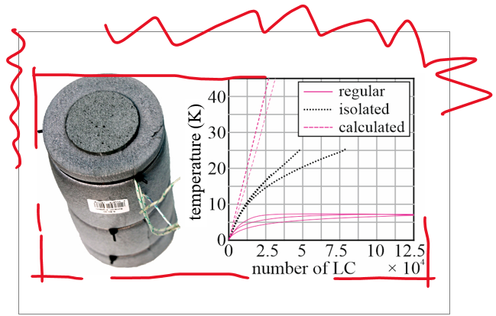 (b) 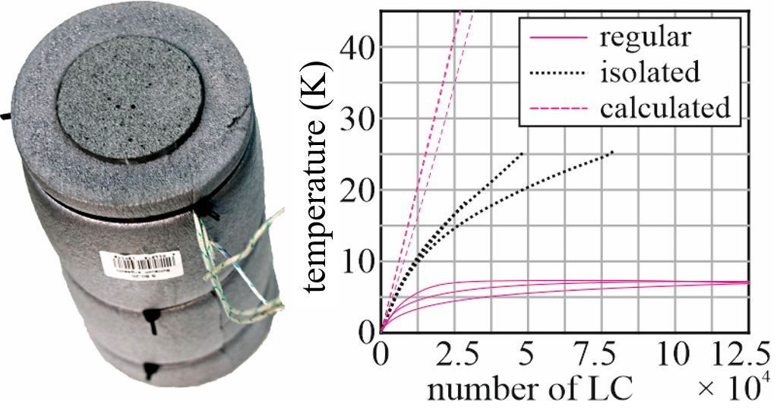
Fig. 2. (a) Illustration with wrong empty space, wrong frame around a diagram and too small font size, (b) correct formatting. (© Melchior Thieme and Silke Scheerer, taken from Scheerer et al. 2026)
(a) 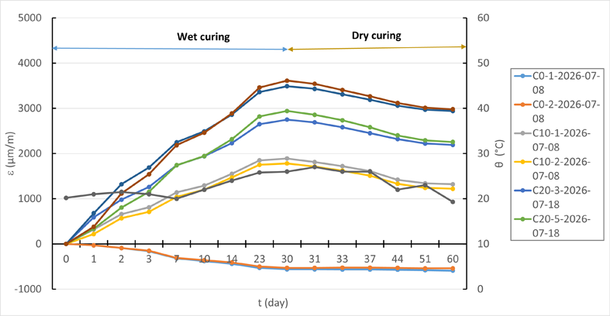
(b) 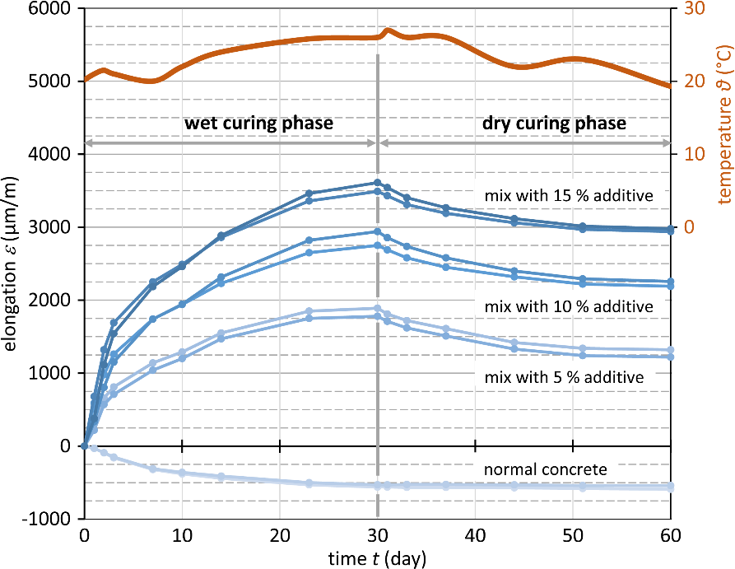
Fig. 3. Two variants of the same diagram; (a) shortcomings regarding, resolution, wrong frame around, font sizes, content of axes’ labels, assignability of lines (similar colors without any principle behind), unclear nomenclature of data lines, incomplete legend, and (b) improved illustration. (data from Mohammed Dhahir, graphics by Silke Scheerer)

Equations, symbols, units
Equations should be centered and numbered sequentially, and, of course, referred to in the text. Place the equation number to the right of the equation within parentheses, right-aligned (use format “Eq”). Examples are Eq. (1) and Eq. (2):

(format “Eq”): K^{t} + e^{u} = f(x) (1)
(reduced blank line = 6 pt)
${\left(x+a\right)}^{n}=\sum_{k=0}^{n}{\left({n \atop k}\right)x^{k}a^{n-k}}$K^{t} + e^{u} = f(x) (2)

(format “1st_Paragr” after an Eq.) Make sure that any subscripts in your equations are legible. When referring to an equation, use the number within parentheses. If possible, use the Symbol font for all special characters or use Equation Editor™ or MathType™. If using MathType, use 10 pt font size with 8 pt subscripts and superscripts and 7 pt sub-subscripts.
For simple equations in the text always use superscript and subscript e.g., A_{F} = b_{t} + c². Do not use the equation editor between text on the same line. Explain each formula symbol in words the first time it is used. Write formula symbols in italics, but not units. Always use the official SI notation. Other unit systems may be used in accordance with established practice, e.g. to designate rebar size, but in such cases the pertinent measures shall also be stated in SI units.

Language, tenses, uppercase and lowercase letters, etc.
Some general rules:
- Language: American English;
- Explain each abbreviation in words the first time it is used.
- Avoid excessive use of acronyms.
- Use dot (.) is as decimal separator.
- Place value and unit in the same line.
- Use a dash when indicating a range of (measured) values, when listing page numbers, or a time period, e.g., 23–33 MPa, pp. 120–130 or November 12–14.
- Things that happened in the past must be written in a past tense.
- One heading of level 1, 2 or 3 requires at least a second heading of the same level.
- Don’t use footnotes.
Regarding dates, please use a consistent format in the text and in the reference list in order to avoid misunderstanding by readers. We recommend to give the month in dates generally in the form of its full name or the name’s abbreviation. A few examples:
- One day: November 1, 2015; Dec. 10, 2016; 09.06.2023;
- Two days: November 1/2, 2015; Dec. 10/11, 2016; 09./10.06.2023;
- Three and more days: November 1–11, 2015; Dec. 10–20, 2016; 09.–22.06.2023;
- Just month and year: June 2015.
Please make use of a suitable spelling control and, even if you consider yourself proficient, you are strongly encouraged to have the text proofread by a native English speaker. Particularly valuable would be a review by a colleague outside your narrow field of expertise, who might query terms or phrases that are not commonly used.
Capitalization often proves to be challenging. Use capital letters only:
- First letter of “true proper nouns” = names of persons (no small capitals!), affiliations, cities, countries, concrete products, and comparable,
- First letter of a sentence, a title, a heading, the first keyword, the figure caption, and the table heading,
- In abbreviations,
- In case of formula symbols and units (if necessary),
- Optional: first letters in lists and table cells.
Examples: finite element analysis (FEM), structural health monitoring (SHM), laser Doppler vibrometer, Gaussian distribution, digital image correlation (DIC), artificial intelligence (AI).

Copyright and editorial policy
Full papers and extended abstracts will be published exclusively in digital form (license expected to be
CC-BY 4.0). Be careful in regard of copyright aspects! As part of the submission process, you will be requested to confirm your consent to your contribution to be published by fib Symposium 2027. Do not submit a paper you have submitted or published elsewhere. The submitting author is responsible for obtaining agreement of all coauthors and any consent required from sponsors before submitting a paper. Any costs and consequences arising from failure to comply with copyright laws shall be borne by the authors.
Submission of a manuscript is not required for participation in fib Symposium 2027.

Conclusions
… should state concisely the most important propositions and achievements of the paper as well as the authors’ views of the practical implications of the results or future research developments.
Acknowledgements
… should follow the Conclusions section, if necessary. The section provides an opportunity to express appreciation to those who contributed significantly to the developed work and to the preparation of the paper. They may be written in a free style and must be brief.
References
The reference list is the last section. It should be arranged alphabetically either by the author or by the publisher, for documents published by organizations and associations (e.g. fib, ISO, ACI, DIN).

Citation in the paper. References in the text should be given with author(s) name(s) and year of publication in parentheses, e.g.: “… see (Neville 1991)”. They may also be quoted with only the year in parentheses, for example: “... according to Neville (1991)”. If the reference is placed in parentheses, please write, e.g.: “… (Abrams 1991; Scheerer et al. 2026; Abrams and Neville 1997)”, compare Fig. 2.
Multiple authors are quoted as indicated by the following examples:
- One author: Abrams 1991,
- Two authors: Abrams and Neville 1991,
- Three and more authors: Abrams et al. 1991.
If several works by the same author(s) are cited, entries should be chronological:
- Neville, A. (2020a), Design ...
- Neville, A. (2020b), Properties ...
Formal notes. In the following, some examples are given that illustrate the desired presentation of references. Please pay meticulous attention to ensuring that your entries are correct in terms of both form (punctuation and order of facts!) and content (completeness!). Your entry must always clearly indicate the type of publication being referred to. The use of commonly accepted abbreviations is recommended. Please
- always add the DOI, URL, or equivalent, if available,
- add number of edition if at least 2 editions of the work are in circulation,
- indicate published works with the supplement “[ed.]” / “[eds.]” in English after the editors’ names,
- indicate special kinds of publications in “[…]” (see examples),
From four or more authors, the abbreviation “et al.” can be used.

Examples. Please use format “Ref”.

(format “Ref”) Adams, A.; Beyer, B. (1999) Book title. 2nd ed., Place of publication: Publisher. DOI/URL book (with author(s))
Beyer, B. (2014) Book title – Subtitle of the book [e-book]. xx. ed., Location: Publisher. DOI/URL digital version of a book
Cho, W. (ed.) (2014) Book title. 5th ed., Place of publication: Publisher. DOI/URL book with editor(s)
DIN ISO 690:2013-10 = standard name (2013) Title of the standard – subtitle. Berlin: Wiley. DOI/URL code/standard
Dresen, K. et al. = chapter’s authors, here: four or more (2001) Chapter title. In Bergmeister, K.; Fingerloos, F. (eds.) Book title, xx. ed., Location: Publisher, pp. 120–140. DOI/URL single chapter from a work with publisher
Eisermann, C. (2026a) Article title 1. Journal Volume(Issue), pp. 99–110. DOI/URL article in a journal
Eisermann, C. (2026b) Article title 2. Journal, first publ. online: 11.12.2026. DOI/URL preview of an accepted article
Faustino, M. (2016) Contribution title – subtitle. In Editor1, F. et al. (eds.) Future of Concrete – Proc. of 12th ABC Congress (ABC2016), Location of event, Country, Place of publication: Publisher, pp. 127–136. DOI/URL conference paper
Google Inc. = owner (2015 = distribution year) Title of the program – subtitle [software]. URL software
Großer, A. (2020) Title – subtitle [master thesis = type of university document]. University. DOI/URL university document
Mustermann, M. (2016) Title – subtitle [dissertation]. TU Berlin, Berlin: Ernst & Sohn. DOI/URL university document
Petroff, M. D. R.; Hildebrandt, V. (1999 = year of issue) Patent title. Patent DE 99 437 34 A1 = number of patent incl. country code, filed Oct. 23, 1980 and issued Feb. 4, 1986. DOI/URL patent
solidian GmbH = owner (2015) Title – subtitle [technical datasheet]. Valid from dd.mm.yyyy. URL data sheet
Walter + Bai AG = owner acc. to contact page (2026 = year of access) Title – subtitle [online]. Place: owner, dd.mm.yyyy or version of the site. URL [accessed on Jan. 13, 2016] website
Walther, K.-H. (2026 = year of access) Title – subtitle [online]. Place: owner, dd.mm.yyyy or version of the site. URL [accessed on Jan. 13, 2016] website with author

